Minutes of Partners meeting
of the Leonardo da Vinci Project No: PL/06/B/P/PP/174014,
titled: “Common Learning Outcomes for European Managers in Construction”,
Warsaw University of Technology, Poland, 3-4 November 2006-11-05

Participants:
- Prof. dr hab. inż. Grzegorz Jemielita - Dean of the Faculty of Civil Engineering, Warsaw University of Technology, (WUT),
- Dr inż. Andrzej Minasowicz (AM), the project Promoter - Department of Construction Engineering and Management, (WUT),
- Mr. Saleem Akram (SA), Director - Chartered Institute of Building (CIOB), Chartered Institute of Building IE (CIOBIE),
- PhD, MSc. David Eaton (DE) - University of Salford (UoS),
- Trevor Mole (TM), President - Association of Building Surveyors and Construction Experts, (AEEBC),
- Dr inż. Paweł Nowak (PN), Vice President - Polish British Construction Partnership (PBCP),
- PhD. Eng. Eugenio Pellicer (EP)- Universidad Politécnica de Valencia (PUV),
- Mr. Janusz Zaleski (JZ), Vice-President - Polskie Stowarzyszenie Menedżerów Budownictwa - Polish Association of Building Managers (PSMB),
- Mr. Marcin Cywiński (MC), student - WUT,
- Mr. Seweryn Wójcikowski (SW), student - WUT.

Program of the meeting attached.

1. Dean of the Faculty, prof. Jemielita, welcomed participants.

2. AM welcomed participants. All participants present themselves and their organizations. AM passed the congratulations to AEEBC joining the ECCREDI.

3. AM presented main ideas of the project and Work Packages of the project (content, date of complition and responsible Partners – according to the application).

4. Partners started discussion on the relevant Work Packages and AGREED THAT:
- WPI – management and administration of the project – all partners will make the link from their websites to the main website of the project: www.leonardo.il.pw.edu.pl (before 30th November 2006), PUV, WUT, UOS, CIOB and AEEBC will appoint the relevant person to become a Project Advisory Board Member (before 30th November 2006).
- WPII – final version of the contents of manuals – all Partners will present their ideas on first draft of the contents before 15th December 2006, the final version of the contents will be ready not later than 15th January 2007. Each partner responsible for writing one of the manuals will prepare contents of that manual, and all partners will discuss and/or add some topics if necessary. Contents of manuals should take under consideration results of the LdV CERT project – Part 1 – “Qualification Standards…” and “The Minimal Scope of Subjects…”
- WPIII – creation of books – first final draft ready not later than 30th September 2007.
- The packages IV to VIII will be discussed in details on the next meetings of partners.
- WPIX – important package connected with dissemination and valorization of the project ideas and results. AEEBC is responsible for the co-ordination of works connected with this package, all Partners contribute and agreed to disseminate the project throughout publications, seminars and conferences for the whole period of the project.

5. AM presented matrix (presented below) of responsibilities for the project derived from application (black dot – responsible, white dot – co-operating). All Partners agreed the matrix.

6. AM and PN presented results of the LdV CERT project No: PL/02/B/F/PP-140 029, titled: „Model of Professional Qualification Structure and New Methods of Promotion, Certification and Mutual Recognition of Managerial Skills in Construction Industry According to the Requirements of E.U.” Manuals and books created during the present project will based on the results from LdV CERT project. All Partners received the Part I and Part II of the aforementioned document: “Qualification Standards and Competences” and “Minimal Scope of Subjects” – the description of tasks of the relevant construction personnel, requirements of knowledge, level of competences and learning requirements.

7. Partners discussed the contents of the books. AM presented the target groups of the prpject and the Matrix of Construction Managers Library (as seen in 2002, numbers refers to books):

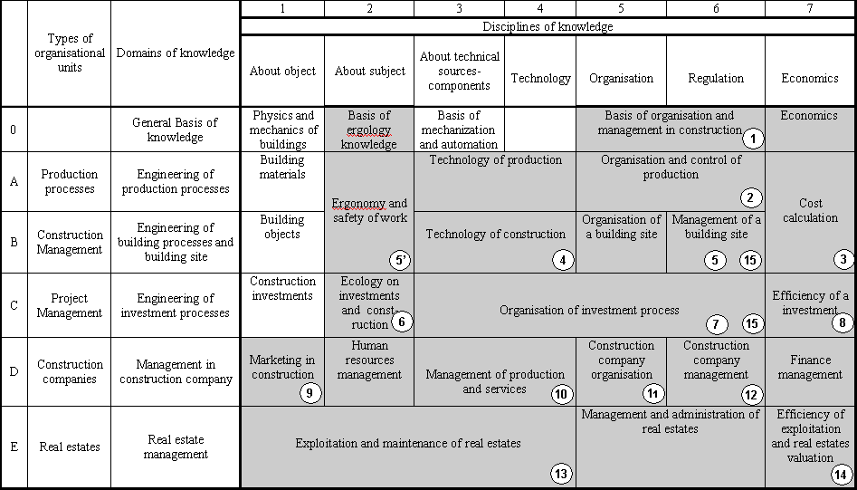

Partners AGREED THAT:
- contents of books will be based on two documents: results of the LdV CERT project (see point 6 of the minutes) and CIOB Code of Practice,
- seven books will be prepared (as it was stated in application, minor changes in titles):
M1. Project Management (M1 PM)
M2. Human Resources Management (M2 HRM)
M3. Partnering in Construction (M3 PC)
M4. Business Management in Construction Enterprise (M4 BMCE)
M5. Asset Management in Construction (M5 AMIC)
M6. Economy and Financial Management in Construction (M6 EFMC)
M7. Construction Management (M7 CM)
- books will refer to the European laws (directives) with no reflection on the detailed national regulations
- as SA mentioned – set of generic European definitions of word phrases and ideas should be included into Project Management book.

- M1. Project Management (M1 PM)
as SA and EP mentioned - PM book will be the first, general book, briefly covering aspects developed in other 6 manuals.
It will be the baseline for all books (“where to go to read more”) – the other books will show detailed tools and methods generally described in M1 PM.
The book will show the best practice in selected areas, referring to European (not national)directives/legislation
Important element of “Communication” will be added.
CIOB (SA) will prepare the basic outline for M1 PM: generic heading and definitions before 15th December 2006.

- M2. Human Resources Management (M2 HRM)
as DE presented – HRM book will consist among other the following elements: safety, European working rules, welfare and human rights

- M3. Partnering in Construction (M3 PC)
as SA mentioned the book will be based on CIOB’s Code of Practice and developed taking under consideration European context.
It will cover aspects of different form or partnering (PPP, PFI, JV)
It could reflect some elements of the RICS report (DE will send relevant link) – changes in the policy and human thinking relevant to the PP projects.

- M4. Business Management in Construction Enterprise (M4 BMCE)
it was agreed that above title will be better that previous “Commercial Management”
The chapters of the book could be as follows:
1. Introduction
2. European Culture and Ethics in Business
3. EU Legal Framework
4. Strategic Management (elements of chapter 4.7. of LdV CERT)
5. Knowledge Management (elements of chapter 4.4. of LdV CERT)
6. Quantitative and Qualitative Decision Making
7. Value Techniques and Risk Management in Construction Company
8. Business Performance and Benchmarking (elements of chapter 4.5. of LdV CERT)
9 . Marketing

- M5. Asset Management in Construction (M5 AMIC)
it was agreed that above title will be better that previous “Real Estate Management”
The chapters of the book could be as follows:
1. Introduction
2. Estate Management (elements of chapter 5.2. and 5.4 of LdV CERT)
3. Property and Facility Management (elements of chapter 5.3. of LdV CERT)

- M6. Economy and Financial Management in Construction (M6 EFMC)
The chapters of the book could be as follows:
1. Introduction
2. International Legal Background
3. Chosen Financial Instruments (loans, mortgages, bonds, financial directives, both for projects and their stages and for different types of construction companies)
4. Chosen financial Techniques (NPV, risk management, cash flows, balance sheets, etc.)

- M7. Construction Management (M7 CM)
The chapters of the book could be as follows:
1. Introduction
2. Preparatory Works for CM
3. Management of Construction Processes Realisation (productivity, performance and benchmarking, as in 3.5, 4.4 and 4.5 of LdV CERT)
4. Health and Safety, Ergonomic in Construction
5. Roles of persons in CM
6. Environmental and Sustainability Management
7. Subcontracting
8. Resources Management and Control
9. Quality Management
(EP sent proposal by email on 9.11.2006)

8. The possible dates of the next meeting were agreed:
- second meeting: 15-16 March 2007, VALENCIA
- third meeting: 5-6 July 2007, DUBLIN
- fourth meeting: ??-?? DECEMBER 2007, SALFORD
- final Conference and the last partners meeting: 17-18 APRIL 2008, WARSAW
(the Promoter will ask LdV Agency for time extension to 30th April 2008)

9. Partners discussed administrative and financial aspects of the project. AM presented some most important information on costs eligibility.
It was agreed that WUT will send to all Partners: the general agreement, (consisting of financial guide and report tables), partners agreements.
DE mentioned minor problem with Salford agreement. It seems like Salford wish to enter agreement with all Partners (not WUT only) and wish to use British law as the law of agreement. The promoter will recognize the problem with Polish LdV Agency and lawyers of WUT.
PLAN OF THE MEETING OF PARTNERS IN THE LDV PROJECT
“Common Learning Outcomes for European Managers in Construction”
3-4 November 2006

Warsaw University of Technology, Faculty of Civil Engineering,
Department of Construction Engineering and Management

Day one – 03.11.2006

10⁰⁰ – Welcome speech, presentation of participants of the project.
10²⁰ – Presentation of the main goals of the project and project’s management plan. Proposal of the detailed three months schedule of work for all of the Partners.
11⁰⁰ – Coffee break
11¹⁵ – Presentation of the result of previous LdV project – “Qualification standards and levels of competence”
12⁰⁰ – Presentation and discussion on planned activities in Work Package I & II.
12³⁰ – Discussion
13¹⁵ – Lunch.
14¹⁵ – Management of the project – financial rules
15⁰⁰ – Discussion
16⁰⁰ – End of the meeting
19³⁰ – Social evening

Day two – 04.11.2006
10⁰⁰ – 12⁰⁰ – Summary of the meeting.

